Exp No:12 Determination and plotting of magnetic and electric field intensity due to infinite long
conductor at any specific point located at H
Date:
Aim:
To write program for Magnetic field intensity of infinite long conductor using SCILAB.
Software required:

• SCILAB version 6.0.1

PROGRAM :
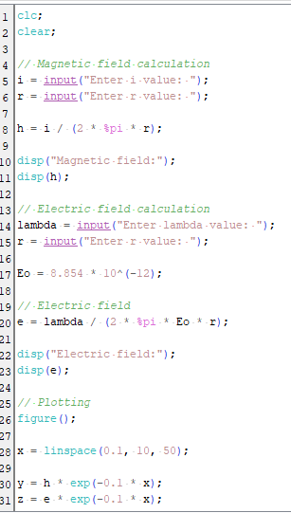
OUTPUT :
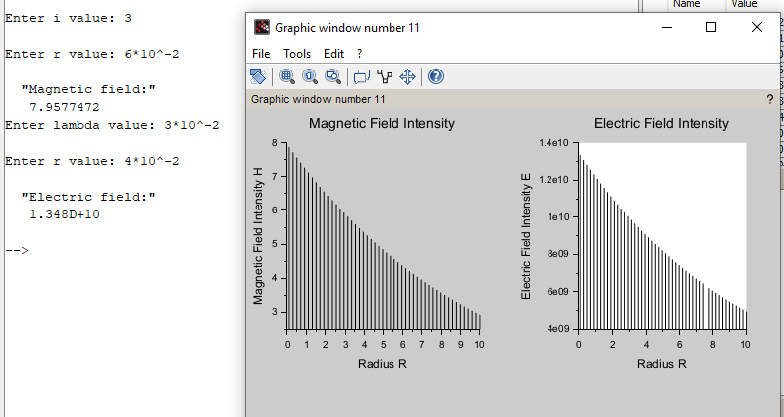
CALCULATIONS :
